# Re-solder CC1110 pins

This can be a fix in the following cases:

* You can connect to EmaLink over bluetooth but EmaLink does not communicate with Omnipod or Medtronic pumps (depending on EmaLink version)
* You have intermittent connectivity issues (red loops)
* You cannot re-flash CC1110 as CC debugger does not turn “green” after connecting and resetting it

ools needed:

* 1. Soldering station with a fine tip (I use a Weller station with a 0.6mm tip)
  2. Soldering flux (I use AMTECH NC-559-V2-TF but any flux for RMA are good)
  3. Soldering wire (I use a 0.35mm led + silver, Interflux IF14 Sn62Pb36Ag2)
  4. Flux cleaner (I use isopropyl alcohol)

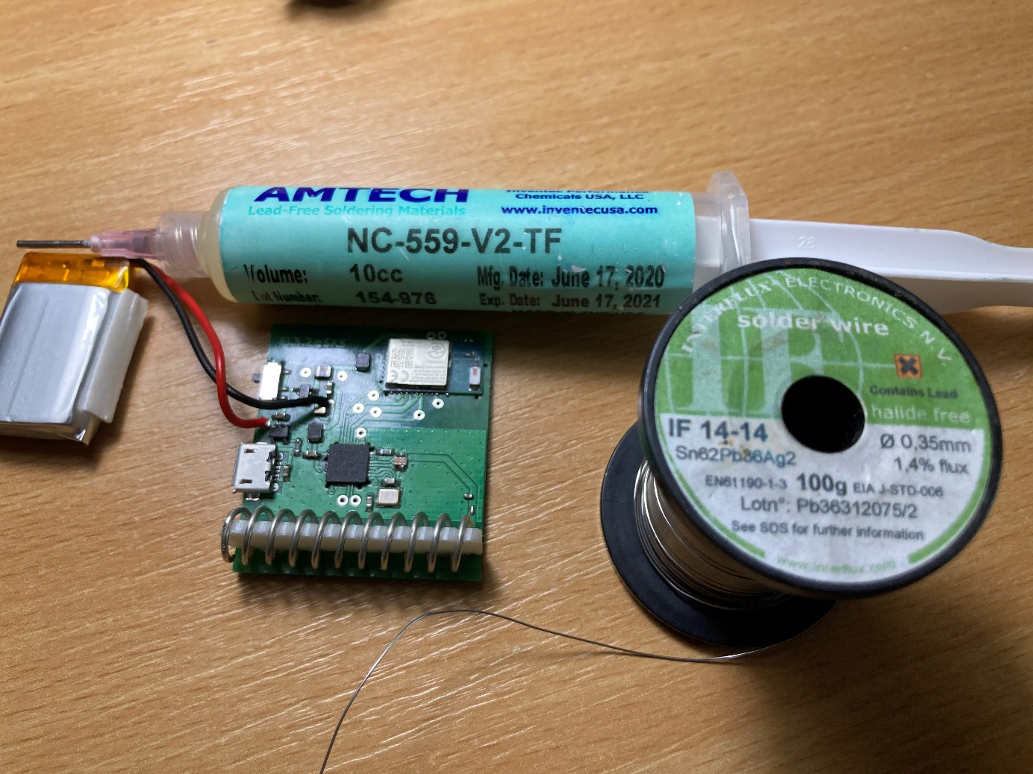

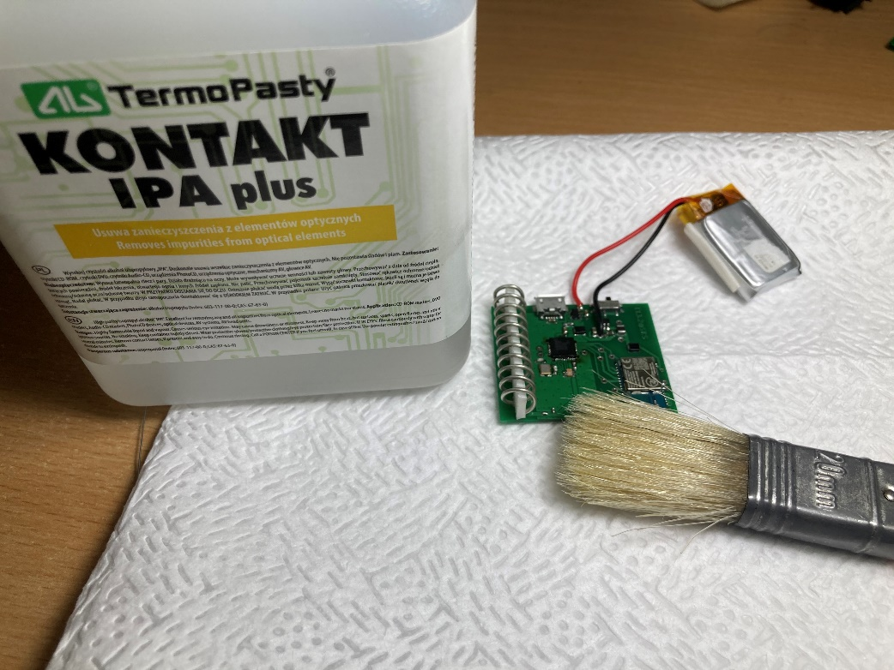

Steps:

1. Apply flux on the 4 sides of CC1110 chip

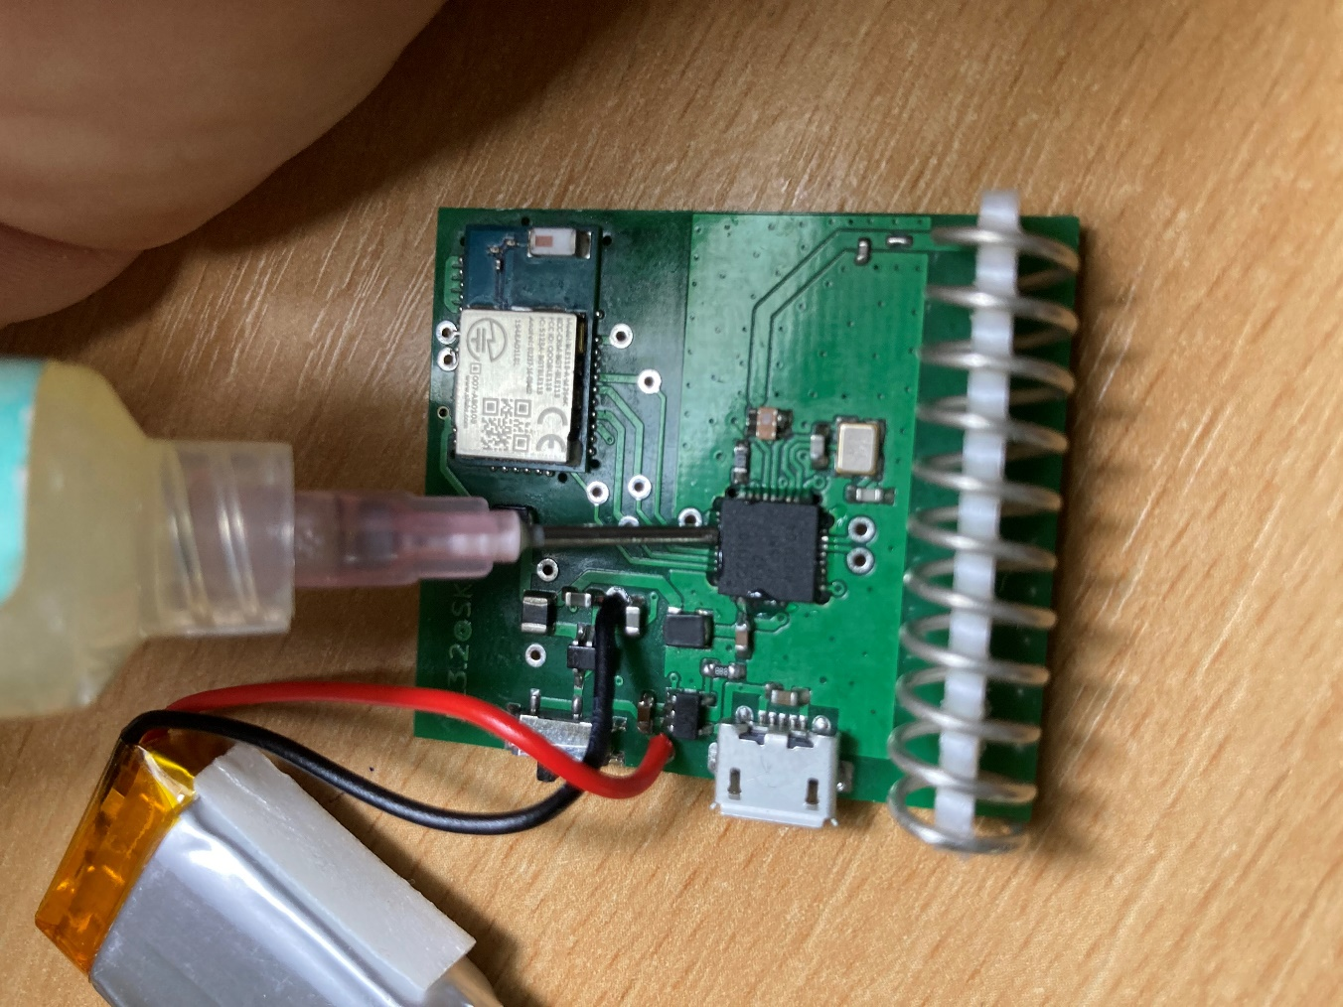

1. Re-solder all pins by slowly dragging the solder tip across all pins. Insist on pins where solder does not stick at first, they may be oxidized. At the end, all pins should look nice and shinny like the small picture below.

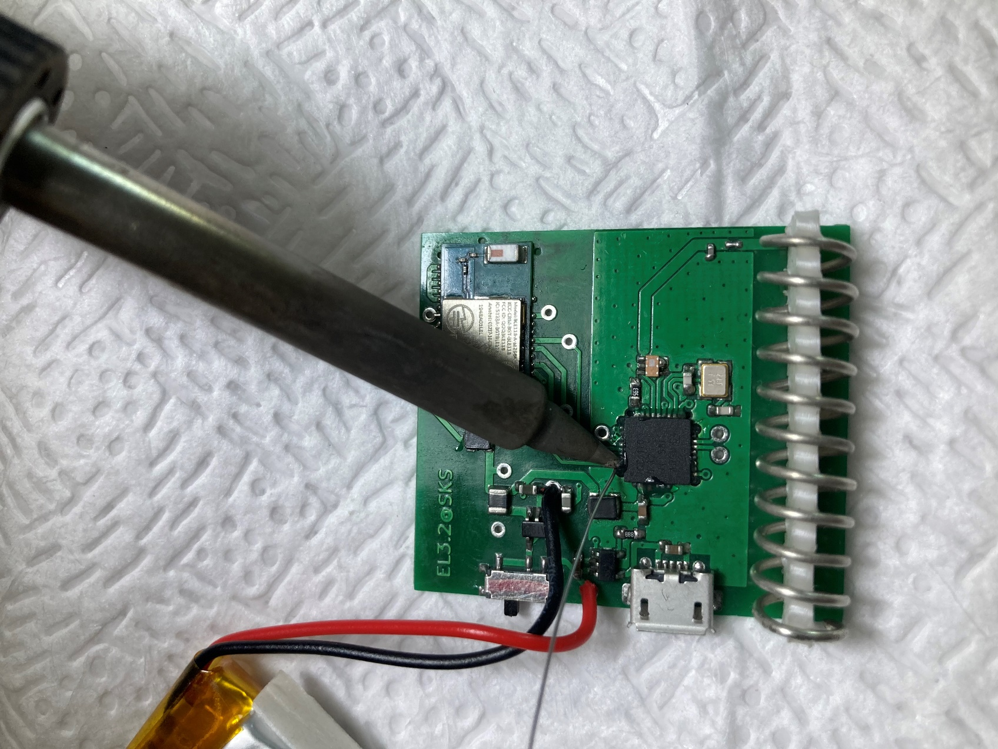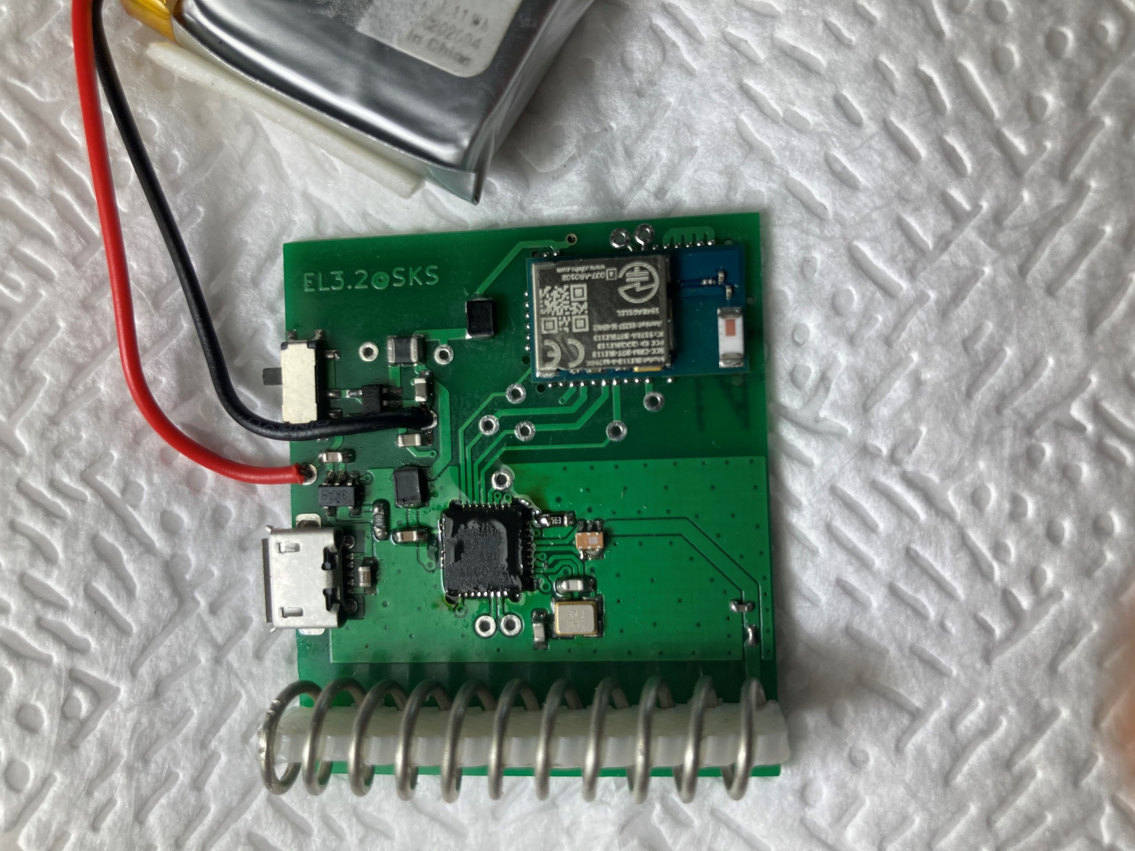

1. Inspect pins with a strong lens or microscope (no pictures available, I could not take pictures though the lens I use). Once I get an USB microscope, I’ll try again…
2. Clean remaining flux with Isopropyl alcohol and a brush

# Re-solder CC1110 ground plate

This can be a fix in the following cases:

* You can connect to EmaLink over bluetooth but EmaLink does not communicate with Omnipod or Medtronic pumps (depending on EmaLink version)
* You have intermittent connectivity issues (red loops)
* You cannot re-flash CC1110 as CC debugger does not turn “green” after connecting and resetting it

Tools needed:

* 1. 0.5mm drill bit + manual drill fixture (may work also with a sharp needle)
  2. Soldering station with a fine tip (I use a Weller station with a 0.6mm tip)
  3. Soldering flux (I use AMTECH NC-559-V2-TF but any flux for RMA are good)
  4. Soldering wire (I use a 0.35mm led + silver, Interflux IF14 Sn62Pb36Ag2)
  5. Flux cleaner (I use isopropyl alcohol)

Steps:

1. Use the drill bit to clean the solder mask from the 5 holes beneath CC1110 chip

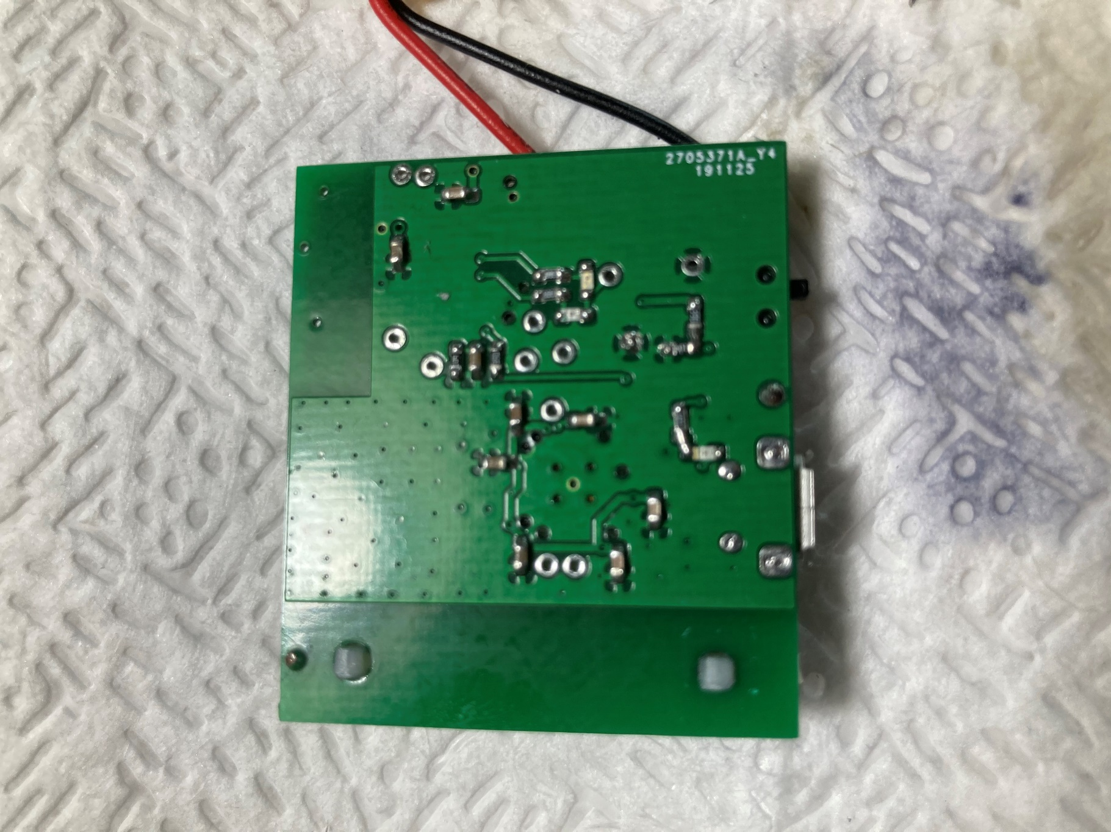

Use the drill to remove the solder mask, no need to push hard. Stop when you see the silver back of the CC1110 chip through each hole

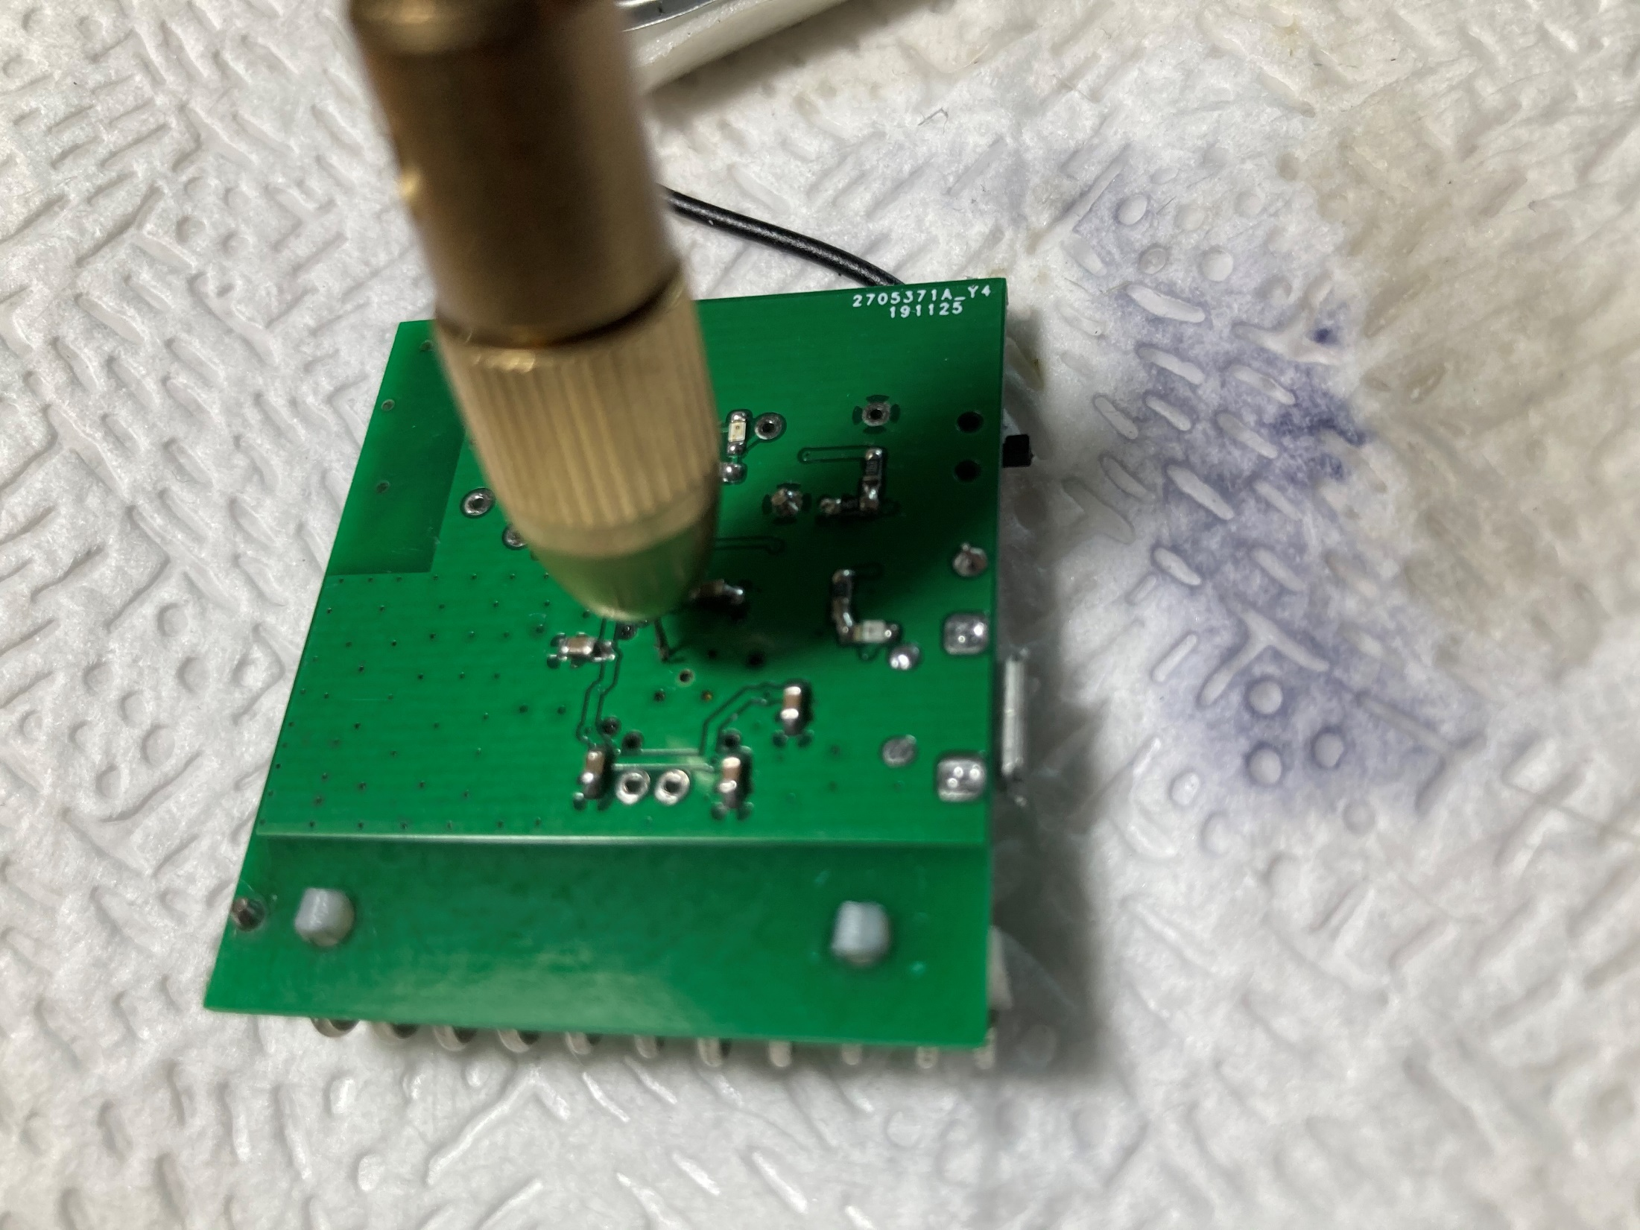

1. Apply flux and then put the solder tip (with solder wire on it) on the big hole in the middle. Heat-up until you see the flux bubling and you can melt solder in the 4 smaller holes. Insert the solder wires in each of the 4 small holes and keep it there until in melts inside.

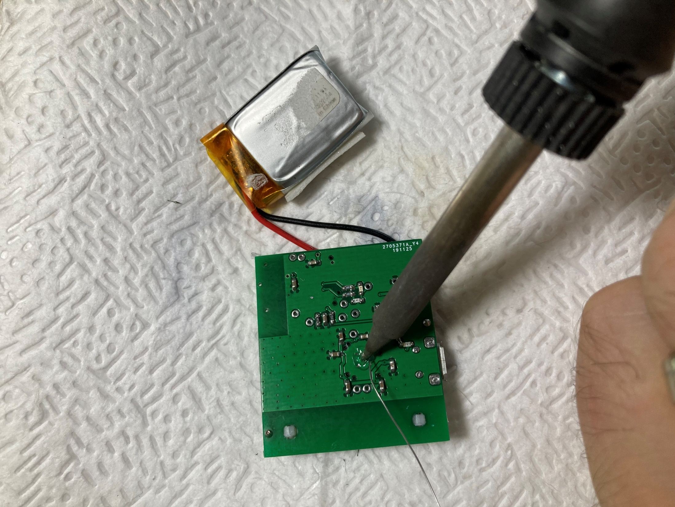

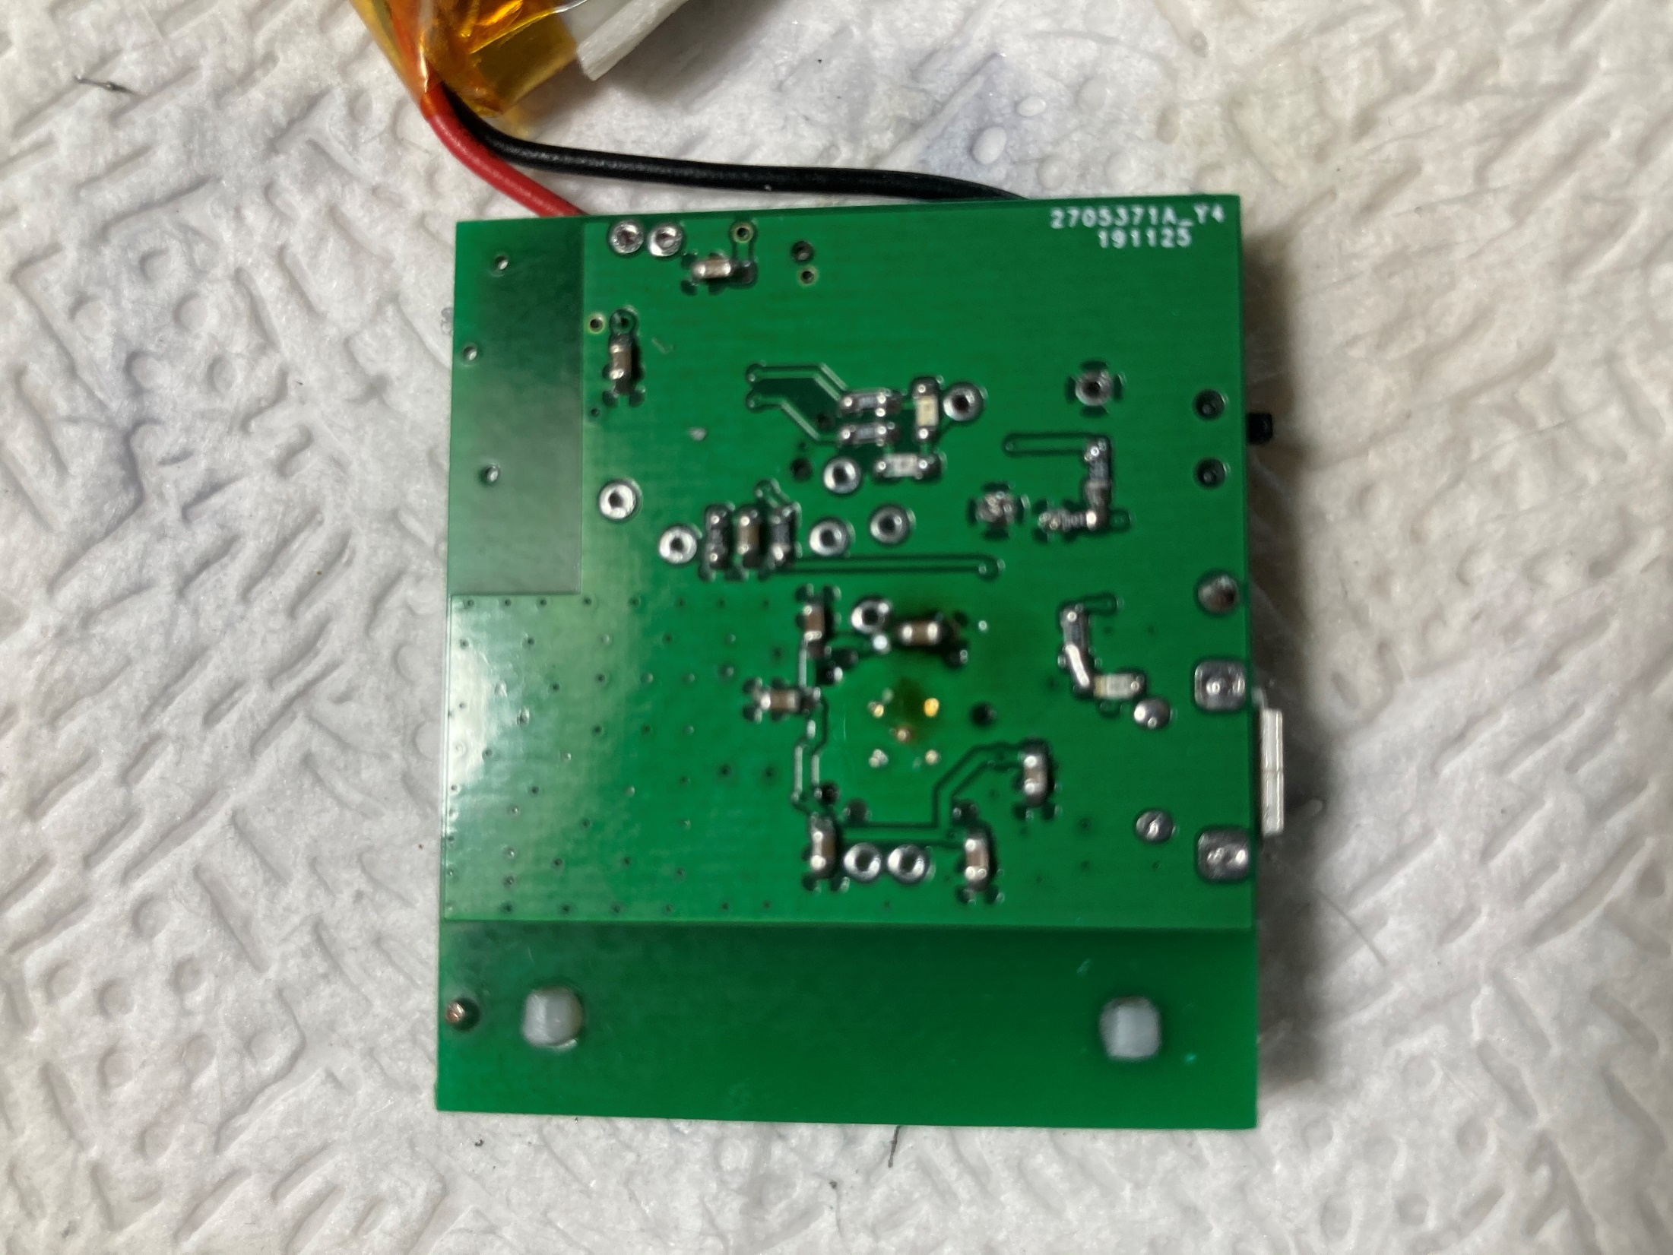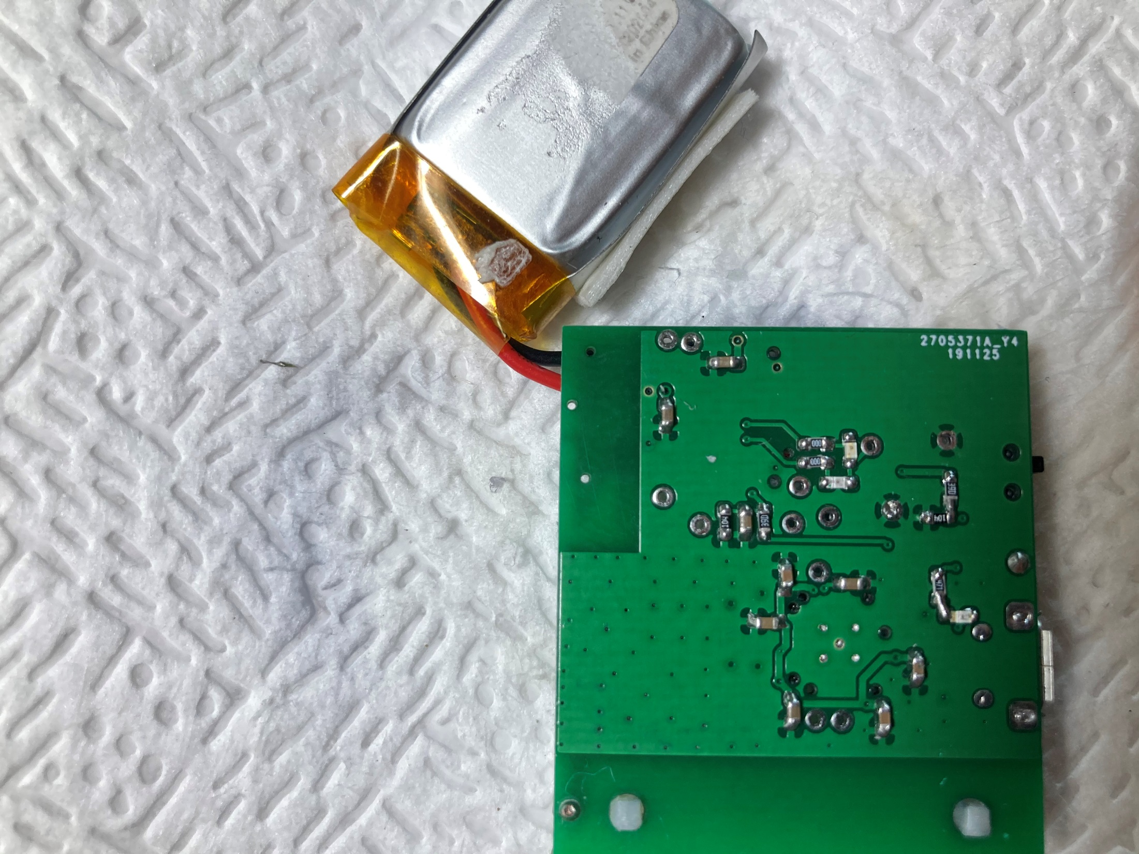

At the end, you want each hole (or at least as many as you can) full with solder.

1. Clean the back of the PCB with a tissue that has flux cleaner on it.